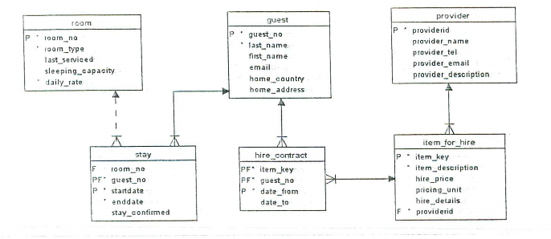

1.

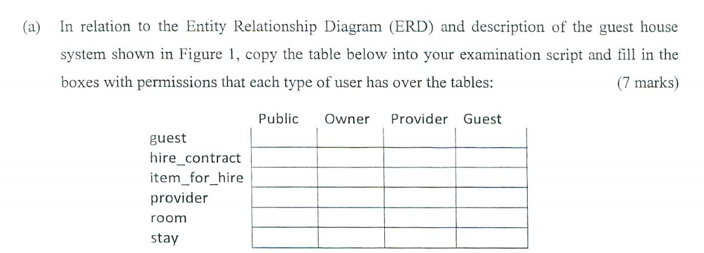

???????



b. select count(guest_no) from stay

where ‘5th jan 2018’ between startdate and enddate’;



select last_name, first_name

from guest

join hire_contract using(guest_no)

join item_for_hire using(item_key)

join provider using(providerid)

where provider_name like ‘Paddy Joe Flanagan’ and date_from like ‘1st jan 2018’;



select providerid, provider_name

from provider

join item_for_hire using(providerid)

where count(item_key) = 0

group by providerid, provider_name;

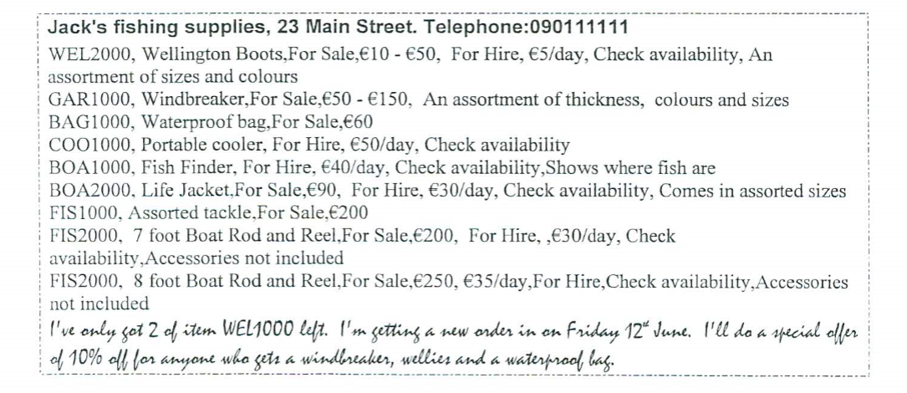

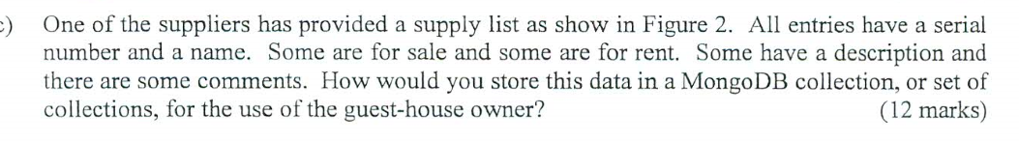

Use supplyList

Db,supplyList.insert({supplier:”Jack’s fishing suppliers”, address:”23 Main Street”, tele:”Telephone:090111111”, supply[{serialNo:”WEL2000”, item:”Wellington”, stateS:”For Sale”, SPrice:”10-50”, stateH:”for hire”, HPrice:”5/day”, Common1:”check availability”, common2:”an assortment of sizes and colours”}]……, comment:”l’ve only……..”})

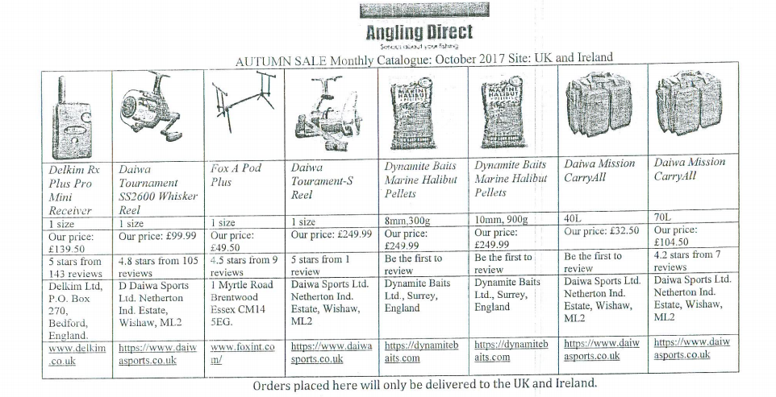

Unnormalization:

Form = CompanyName + date + site + {image + Name + Size1 + Size2 + Price + evaluation + noOfReview + address + website}

1NF:

Form = CompanyName + date + site

F1 = image + Name + Size1 + Size2 + Price + evaluation + noOfReview + address + website + CompanyName

2NF:

Form = CompanyName + date + site

F1 = companyName + Name + image + Size1 + Size2 + address + website

F2 = Name + Price + noOfReview + evaluation

3NF:

Form = CompanyName + date + site

F1 = companyName + Name + image + Size1 + Size2 + address

F2 = Name + Price + noOfReview + evaluation

F3 = Name + Website

Image

Website

companyName

Name

Image

Size1

Size2

Address

Name

Price

noOfReview

evaluation

companyName

date

site



3.

a. 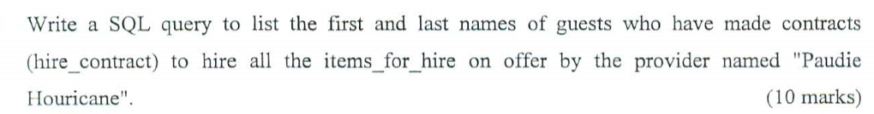

create or replace view B as (select first_name, last_name from guest, count(H.item_key)

join hire_contract H using(guest_no)

join item_for_hire I using(item_key)

join provider using(providerid)

having provider_name like ‘Paudie Houricane’;

)

Select first_name, last_name from B

Group by first_name, last_name

Having count(H.item_key) = (select count(*) from item_for_hire join provider using(providerid) where provider_name like ‘Paudie Houricane’);

Or

Select first_name, last_name

From guest G

Where not exists(select * from item_for_hire I join provider using(providerid) where provider_name = ‘Paudie Houricane’

And not exists (select * from item_contract H where H.guest_no = G.guest_no and H.item_key = I.item_key ))

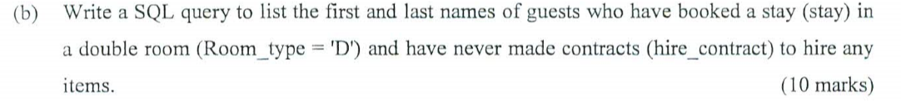select first_name, last_name

From guest

Join stay using(guest_no)

Join room using(room_no)

Join hire_contract using(guest_no)

Where room_type like ‘D’ and count(item_key) = 0;

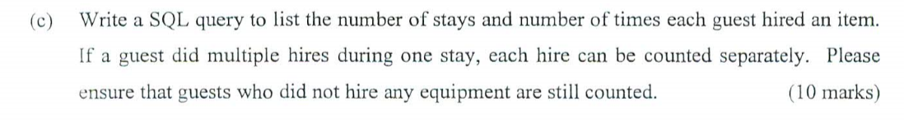select guest_no, count(guest_no), count(item_key)

From guest

Join stay using(guest_no)

Left Outer join hire_contract using(geest_no)

Group by guest_no;

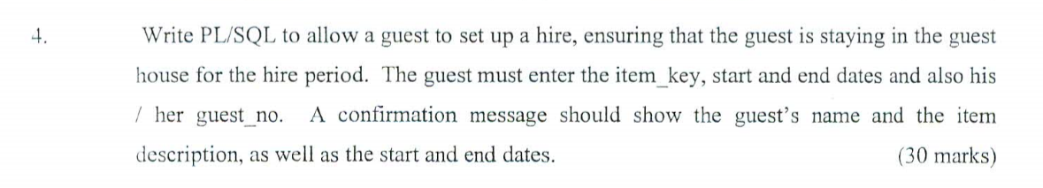declare

V_Gno guest.guest_no%Type:=’&guestNo’;

V_item hire_contract.item_key%Type:=’&itemK’;

V_startDate hire_contract.date_from%Type:=’&startDate’;

V_endDate hire_contract.date_to%Type:=’&endDate’;

V_no integer :=0;

V_Gname String;

V_IDesc String;

Begin

Select count(guest_no) into V_no from stay where guest_no = V_Gno;

If(V_no > 0) then

Insert into hire_contract(item_key, guest_no, date_from, date_to) values (V_item, V_Gno, V_startDate, V_endDate);

Select lastname into V_Gname from guest where guest_no = V_Gno;

Select item_description into V_IDesc from item_for_hire where item_key = V_item;

DBMS_OUTPUT.PUT_LINE(V_Gname, V_IDesc, V_startDate||’ to ’|| V_endDate);

EXCEPTION

WHEN OTHERS THEN

DBMS_OUTPUT.PUT_LINE('Error number '||SQLCODE||

' meaning '||SQLERRM||'. Rolling back...');

ROLLBACK;

END;